## Patient SEARCH

|  |  |
| --- | --- |
| User Name: ……………………………………………. | Trainer Name: Ruchira Ariyasinghe |
| User Sign. : ……………………………………………. | Trainer Sign. : ……………………………………………. |

**Patient SEARCH**

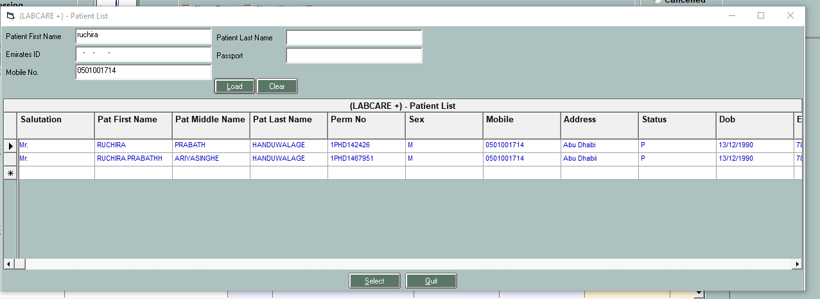

User can search previous registered patients using the patient name , Last name , mobile number , emirates id and select the patient . In this was no need to fill the patient demo details again.